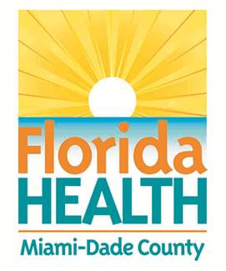
FLORIDA DEPARTMENT OF HEALTH IN MIAMI-DADE COUNTY
SCHOOL HEALTH PROGRAM
ROLES AND RESPONSIBILITIES: SICKLE CELL CRISIS

Student: ___________________________ DOB: ____________ Teacher: _____________ Grade: _______

Parent/Guardian & Phone(s): ___________________________________School Year: __________________

SICKLE CELL DISEASE ACTION PLAN: Refer to the attached Sickle Cell Crisis Action Plan.

School Responsibilities/Agreements | Family Responsibilities/Agreements | Student Responsibilities/Agreements
1. Location medication is kept:  Trained staff authorized to administer medication (review plan, recognize symptoms and respond) | 1. Provide medication for school  site/replace any expired medication | 1. Report early warning signs of sickle cell  episode
2. Staff to contact 911/parent/guardian: | 2. Keep school staff informed of any  changes in student condition or  medications
3. Staff to direct EMS to the emergency: | 3. Parent or designated adult, as noted on  emergency contact card, to respond to  school when called.
4. CPR certified staff:

5. Substitute teacher instructions:

.

________________________________ ___________________
Parent/Guardian Signature Date
________________________________ __________________
Principal or School Administration Designee Date
____________________________ _________________
School Nurse Date

